How to Opt-In for Valley College SMS Texting

1. Log in to the student portal at http://web4059.campusnet.net (don’t forget to use Google Chrome).
2. Click the “My Profile” tab on the left, and then click “My Information.”
3. Click the “SMS” tab (see below).
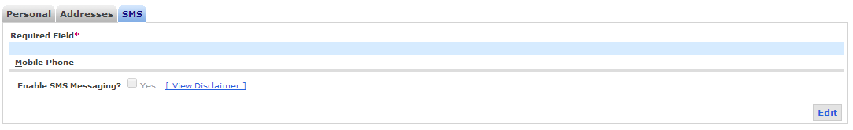
4. Click “Edit” in the lower right corner, put in your mobile phone number, and check “Yes” in the “Enable SMS Messaging” check box. Then, read the disclaimer and click “Accept” to allow SMS messaging.
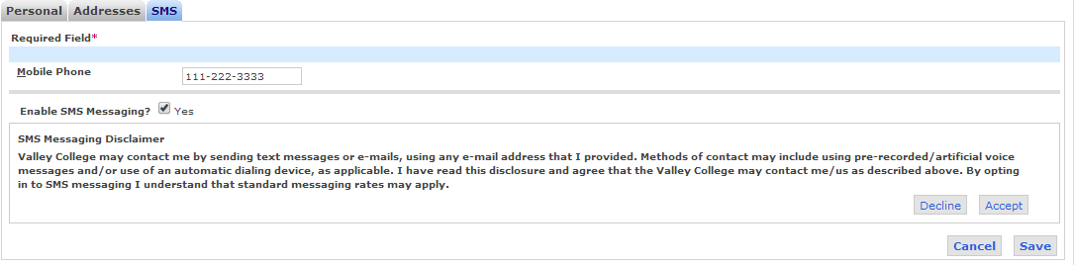
5. Choose your mobile provider from the drop-down box, and then click “Save” to finalize.
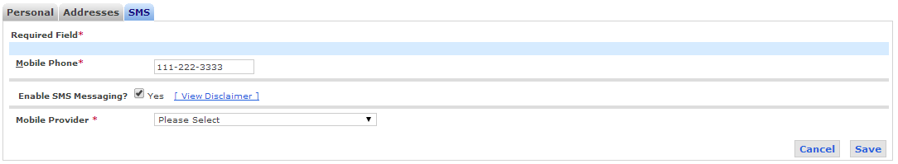

Please Note: If at any time you no longer wish to receive SMS messages from Valley College, you can change your preferences by repeating Steps 1-4 above. When you click “Edit” you can simply uncheck “Yes” in the “Enable SMS Messaging” box and click “Save.” After saving your updated preferences you will no longer receive SMS messages from Valley College.

